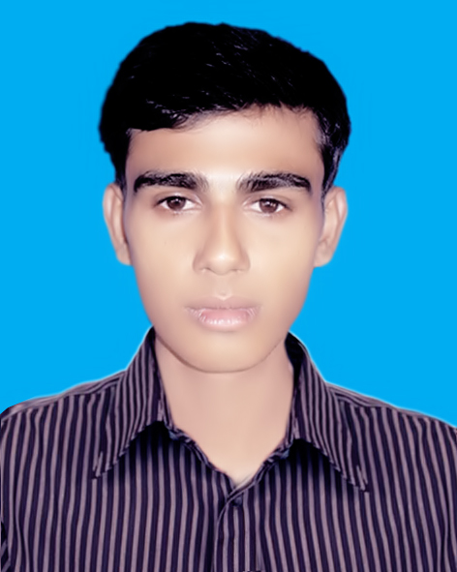
Curriculum Vitae

MD. SAKIL SOWDAGAR
Vill: Sowdagar Bari,
P.O: Bakshigonj.
P.S: Bakshigonj,
District: Jamalpur.
Mobile : 01925576161
Email : shakil-sawdagor@hotmail.com

OBJECTIVE:

Looking for hard and challenging job where I will have the scope to utilize my potentiality, adaptability and skill to do something innovate and from where I will be able to enhance my knowledge.

ACCADEMIC QUALIFICATION:

Bachelor of Arts ( Hon’s)2nd year running
Department : Islamic History
Institute : Tejgoan University College , Dhaka

Higher Secondary Certificate (H.S.C)
Achievement : 2.40
Passing Year : 2010
Group : Humanities
Institute : Bokshigonj Kiamat Ullah College
Board : Dhaka

Secondary School Certificate (S.S.C)
Achievement : 2.50
Passing Year : 2008
Group : Science
Institute : Bokshigonj N.M. High School
Board : Dhaka

Experience:

- I Have an experience as brand promoter of various type of products of them UHT Milk(School Activation program), Milk man(School activation program), Mr. Noodles(School Activation Program).

COMPUTER LITERACY:

Operating System : Windows 98/2000, Windows XP, MS Word
Others : Internet Browsing, E-mail, Software installation

PERSONAL DETAILS:

Name | : | Md. Sakil sowdagar
Mother’s Name | : | Most. Shahina Begum
Father’s Name | : | Md. Mister Sowdagar
Present Address | : | Vill: Sowdagar Barri,  P.O: Bokshigonj.  P.S: Bokshigonj, District: Jamalpur.
Permanent Address | : | Vill: Sowdagar Barri,  P.O: Bokshigonj.  P.S: Bokshigonj, District: Jamalpur.
Date of Birth | : | 20 Dec 1992
Nationality | : | Bangladeshi
Religion | : | Islam (Sunni)
Marital Status | : | Single
Sex | : | Male
Height | : | 5'7.5"

Signature
Md. Sakil

